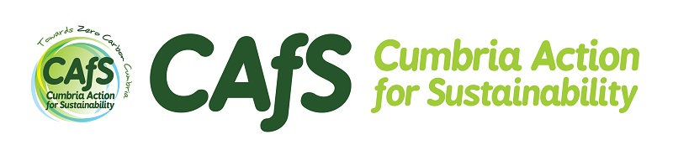

Change your home from cold to cosy!
If you’re struggling with high heating bills or a cold home, take advantage of our Cold to Cosy Homes service – FREE for all eligible Cumbrian households.

About Cold to Cosy Homes Cumbria
Cold to Cosy Homes Cumbria offers free energy-saving advice and equipment, along with referrals for a range of other support, to help you make your home warmer and more comfortable. The service is available across Cumbria, and has already helped hundreds of households to save money on heating bills and do their bit for the planet by using less energy.
It is free for people who meet one of the eligibility criteria, including a range of health conditions, income levels and other circumstances, from bereavement to periods of homelessness.

What you get
- A free advice phone call from a qualified assessor, so that we can find out more about your home and the services you could benefit from. These might include:
- Energy-efficient equipment such as LED bulbs, sent to you in the post
- Professionally installed draughtproofing
- Advice and help with your energy bills and switching energy tariff
- Being referred to other support and advice agencies or for other grants
The service is provided by Cumbria Action for Sustainability, and we’ve been helping people to save energy in their homes for more than 20 years. It is funded by the Energy Industry Voluntary Redress Scheme and we work in
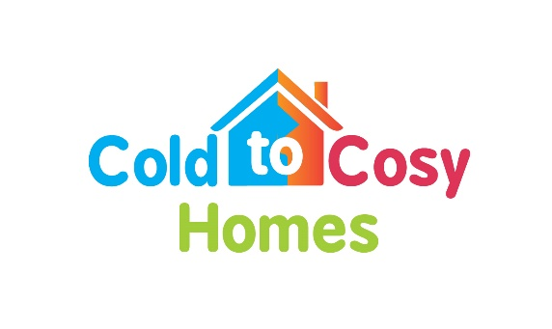
cosyhomes@cafs.org.uk 01768216500

